Nexus Kids Camp 2015
Track Leaders Job Description
The tracks are held during the afternoon portion of the Nexus Kids Camp. We hold two tracks slots/ afternoon. Depending on the number of campers, we offer multiple options for each time slot.
This year in San Diego, we will be offering the following tracks on Friday afternoon and possibly on Wednesday after.
- Track I Choice
Art Studio Fun with Science Basketball/Dodgeball Early Childhood Organized Games/Activities

- Track II Choice
Art Studio Fun with Science Dance Studio Early Childhood Organized Games/Activities

1. Each Track is 1 hour long and includes clean up time as well. Every track leader must prepare a lesson plan for the track they will be leading or assisting. Every track has two leaders, for example the Art Studio, Daniel Lee (Graduate of UCSD) and Lina Kim will be leading and preparing the track lesson.
2. Due to the nature of the camp, whatever Art project you decide to do, you must be able to finish the entire project within the 1hr including clean up.
3. The track leaders will provide a detailed lesson of what they will teach, materials they will need, and make a sample project. They are responsible for giving instructions and for making sure that the project is age appropriate.
4. As many of the campers will be coming from out of town, the art project needs to be transportable and not bulky. Also, the art project is a learning project, something where the children can acquire new skills. We are not looking for art projects that are premade like from Oriental Trading (used during VBS), they need to be projects that children want to keep and hang onto.
5. The track leaders are also responsible for making sure that the work area is safe and that there is instructions given to crew leaders (Nexus Kids Camp Volunteers who will escort a group of students to each track) so that they can be of assistance to you and the campers.
6. The track leaders are also responsible for setting up and cleaning up the work area in preparation for the next track.
7. As this is a Christian camp for our children, consider how you might engage in conversation with the campers as they do their project. This is a great time to get to know them and to share Christ with them.

Sample Lesson
Spray Dye tshirt or bandana
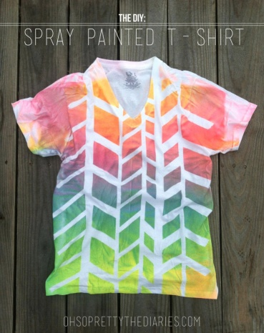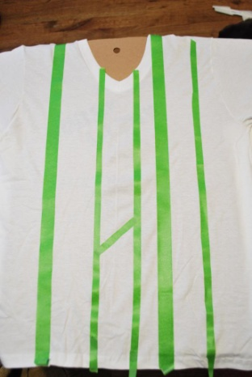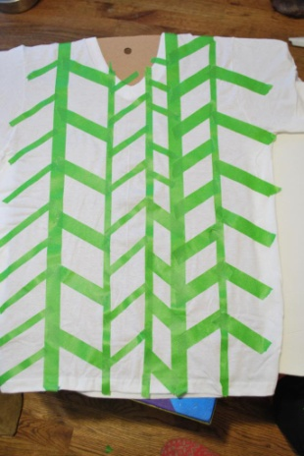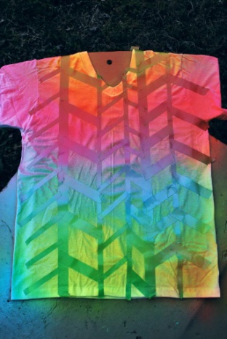

Art Project 2
Teach children how to paint landscape, birds, flower, or San Diego (reminder of their trip). You would use a smaller canvas for transport purposes or use watercolor paper and roll them up. Give step by step instructions of producing their masterpiece.
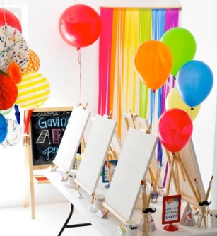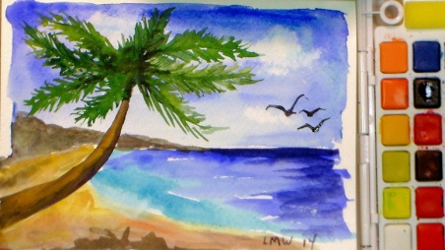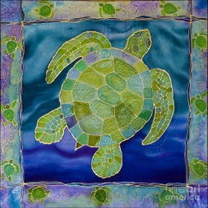

Art Project 3
Finger Puppets for Kids. If finished early, provide a script for them and have them act it out.
